**MultiLine Text / Break Text in React Native**

In this Example of MultiLine Text / Break Text in React Native, we will see how can you break the text of a Text Component in multiline using a new line character

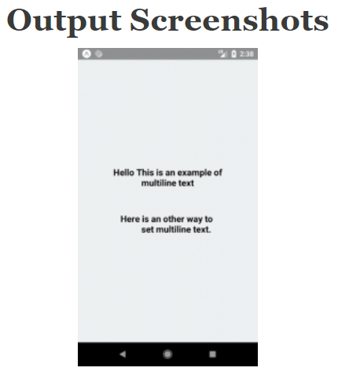

//This is an example of Multiline Text

import * as React from 'react';

import { Text, View, StyleSheet } from 'react-native';

export default class App extends React.Component {

render() {

return (

<View style={styles.container}>

<Text style={styles.paragraph}>

Hello This is an example of

{'\n'}

multiline text

</Text>

<Text style={styles.paragraph}>{`Here is an other way to

set multiline text.`}</Text>

</View>

);

}

}

const styles = StyleSheet.create({

container: {

flex: 1,

justifyContent: 'center',

paddingTop: 30,

backgroundColor: '#ecf0f1',

padding: 8,

},

paragraph: {

margin: 24,

fontSize: 18,

fontWeight: 'bold',

textAlign: 'center',

},

});